SeaLife Tech advice
For Authorized SeaLife Service Centers and Distributors

Date: September 21, 200

Subject: Digital Pro Flash (SL961) - flash does not power on.

Applies to: All Digital Pro Flashes

Symptoms: When turning switch to ON position, the flash ready light does not turn on, even after installing new or freshly charged batteries. The flash will also not TEST fire. This problem may be intermittent – In other words, the flash works fine at one moment and does not work a few minutes later.

Cause: The problem may be caused by a weak magnet in the magnetic power switch.

Solution: To troubleshoot and confirm the power switch magnet is weak, take another powerful magnet and hold it directly over the ON position of the flash head. After the flash ready-light turns on, place the magnet directly over the TEST position on the flash head. If the flash charges (i.e. ready light on) and then fires when holding magnet over the TEST position, it is confirmed the switch has a weak magnet. 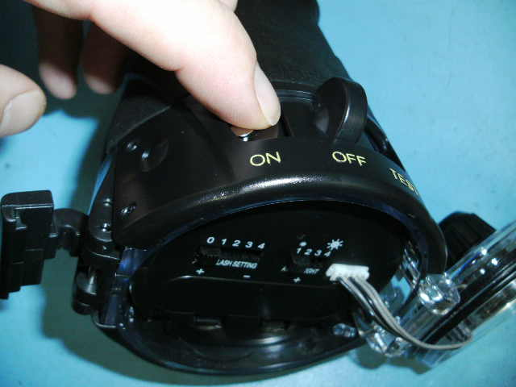
Hold another powerful magnet
Over ON position

To repair, remove the power switch assembly (2 screws on top of flash) and replace the small, round magnet located inside the switch. Contact SeaLife service department to order a replacement magnet.
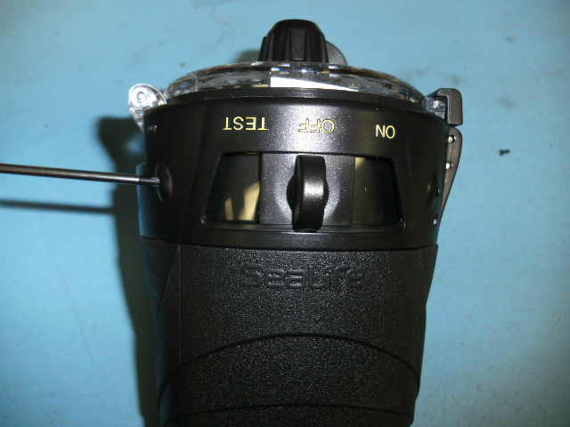
2 Phillip head screws

Insert a flat-head screwdriver between the switch assembly and the flash housing at the hinge side of the flash housing and gently pry up the switch assembly.
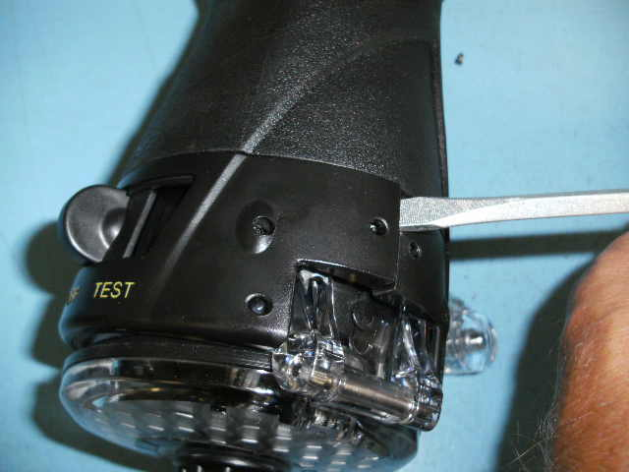

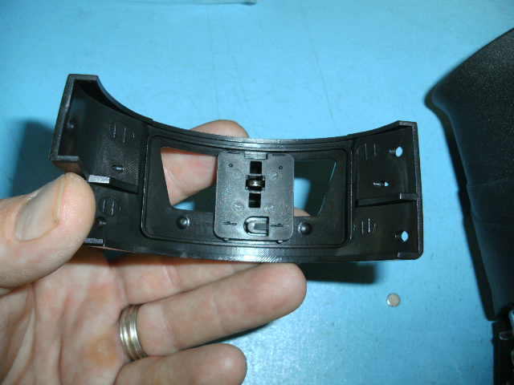
Insert new magnet.

If the flash still does not power on after the above test, then check the battery power using a volt meter and inspect and clean the battery contacts. If this does not solve the problem, please contact the SeaLife Service Center in your country

Warranty: Yes

